**Final Year Project**

**(Draft report, advanced version of artefact)**

Full Name : Prajwal Thapa

Student Number : 2333328

Course : BSC (Hons) in Computer Science

University Email : P.Thapa17@wlv.ac.uk

Supervisor : Mr.Sangay Lama

Reader : Subash Bista

Submission Date : 31/03/2025

**MCS COMMITTEE ON THE ETHICS OF RESEARCH**

**Registration of a Research Project**

This form must be completed by the Researcher(s) and, in cases where the applicant is a student, the project Supervisor to determine if the project requires approval by the FSE Research Ethics Committee.

|  |  |
| --- | --- |
| **YOUR DETAILS** | |
| **First Name: Prajwal Surname: Thapa** | |
| **Student Number: 2333328 Supervisor: Mr. Sangay Lama** | |
| **Course: BSc (Hons) Computer Science** | |
| **Project Title: Development of gender identification system for malls.** | |
| **YOUR PROJECT** | |
| **State in no more than 100 words the problem(s) your project is aiming to address**  This project is all about automating the process of counting the number of male and female visitors at a particular location for the necessary project work. Manual surveys are cumbersome, time-consuming, labour-intensive, and error prone. There is no real-time insight into what happening in dynamic environments. This project implements the AI and IoT to completely eliminate human interventions, reduced operational costs, mostly improves data accuracy, instant analytics, and providing scalability and security of the data. Thus, it becomes the most appropriate solution for sectors such as retail, public spaces, and event management. | |
| **Will the information or artefact resulting from your project be available externally to the University?** | **~~YES~~ / NO**  If yes, please complete an External Agreement Form |
| **Will your project involve:** **(a) Human participants**   1. **Data about humans** 2. **Sensitive information** | **~~YES~~ / NO**  If yes, please complete Page 2 of this form. Otherwise, please sign the top of Page 3, and if necessary pass it on to your supervisor. |

1

|  |  |  |  |
| --- | --- | --- | --- |
| **Human participants** | | **Yes** | **No** |
| If your proposal involves healthy adult participants, does the project have characteristics that may be detrimental to their physical or mental wellbeing? | |  |  |
|  | Does the proposal involve vulnerable participants (for example, are they under 18 years of age, do they have a disability or are mentally unable to consent)? |  |  |
| **Priva** | **cy** |  | |
|  | Does the proposal involve processing of genetic information or personal data (e.g. health, sexual lifestyle, ethnicity, political opinion, religious or philosophical conviction) |  |  |
|  | Does the proposal involve tracking the location or observation of people without their knowledge? |  |  |
| **Rese** | **arch on Animals** |  | |
|  | Does the proposal involve research with animals? |  | |
| **Rese** | **arch Involving Developing Countries** |  | |
|  | Is any of the research involving one of the [Least Developed Countries?](http://unctad.org/en/pages/aldc/Least%20Developed%20Countries/UN-list-of-Least-Developed-Countries.aspx) |  |  |
| **Dual** | **Use** |  | |
|  | Does the research have direct military application? |  |  |
| Does the research have the potential for terrorist abuse? | |  |  |

**This form should be filled in and submitted to the corresponding assignment on Canvas by the student (in the case of student applicants).**

**Print this page and fill in with your supervisor (the student may also want a copy for themselves).**

2

**Abstract**

This is an advanced technological solution that has AI gender classification and crowd analysis. It is endowed with deep learning computer vision and IOT processing of data upload to classify gender in a crowded area in real-time. This is focusing on crowd management, security monitoring, and demographic analysis, besides addressing other ethical and privacy considerations. This project uses Convolutional Neural Networks (CNNs), specifically ResNet to reach high accuracy in gender classification under different environmental conditions, poor lighting and occlusions, and different angles.

The research investigates the nexus of AI within real-time surveillance systems， such that the developed model is efficient and well adapted for mass-scale applications. Some paramount challenges such as data pre-processing, optimization of real-time performances, and compliance with privacy standards were addressed using the protocols and advanced models of secure dataset handling. Moreover, the Agile methodology structured the project in order to permit continuous enhancements based on the model performance and real testing in reality.

Thus, but not exhaustively, the study critically evaluates the socio-ethical and techno ethical implications of AI gender classification. Final observations suggested that deep learning models can vary considerably in improving demographic analytics and security systems yet pose issues of identification protection provided these models are implemented through frameworks that are privacy aware.

This document describes the entire system development life cycle, from the identification of the problem and methodology selection through implementation, evaluation, and recommendations for the future. The results are revealing the possible contribution of AI to enhanced security in towns, retail analytics, and automated crowd monitoring, thus paving the way toward advanced AI-powered surveillance and demographic studies.

**Contants**

**Table of Contents**

**Introduction** 9

**Project Brief** 9

**AI Implementation** 9

**Aims** 11

**Objective** 11

**System Overview** 12

**Data training** 15

**Data training loss/accuracy** 15

**Sub-system Used** 17

**Academic Question** 24

**Scope and Limitation of the project** 28

**Report Structure** 30

**Literature Review** 32

**Introduction** 32

**Literature Review 1** 33

**Literature Review 2** 34

**Literature Review 3** 36

**Literature Review 4** 37

**Literature review 5** 38

**Literature Review 6** 39

**Literature review 7** 40

**Literature Review 8** 41

**References** 42

**Project Methodology** 43

**Justification of Methodology Selection** 45

**Evidence of Project Management** 47

**Different Technology and Tools used for the project** 48

**SRS** 50

**Modelling Diagrams** 51

**FDD(Functional Decomposition Diagram)** 51

**Class Diagram** 52

**Data Flow Diagram** 53

**Gantt Chart** 54

**Testing** 55

**Data training** 55

**Data training loss/accuracy** 55

**Conclusion** 56

**Critical Evaluation of the Project** 58

**Self-Reflection on Report** 58

**Findings and Process** 61

**Planning, Management, and Quality of Sources Found** 65

**Self-Reflection** 66

**Table of Figures:**

Figure 1: SRS 50

Figure 2: FDD 51

Figure 3: Class Diagram 52

Figure 4:Data Flow Diagram 53

Figure 5: Gantt Chart 54

Figure 6: Data Training 55

Figure 7: Dara accuracy 55

# **Introduction**

## **Project Brief**

Development of the AI model gender classification and crowd analysis system using advanced computer vision techniques forms the basis of project implementation. The system uses a webcam in a specific field of view and incorporates an artificial intelligence algorithm capable of real-time detection and categorization in either male or female categories. This collected data will help analyse the gender composition of visitors in a defined area for better resource allocation, security concerns, and crowd analysis.

The problem domain in this project is concerned with automated crowd analysis and demographic classification without human intervention. Traditional survey methods would consider the human factor, in terms of labour, time-consumption, and also could be inaccurate sometimes. This project thus becomes a technical solution, and automation reduces the human factor, increases efficiency, and ultimately ensures data accuracy. The problem domain in this project is concerned with automated crowd analysis and demographic classification without human intervention. Traditional survey methods would consider the human factor, in terms of labour, time-consumption, and also could be inaccurate sometimes. This project thus becomes a technical solution, and automation reduces the human factor, increases efficiency, and ultimately ensures data accuracy.

### **AI Implementation**

#### **AI Aspect Addressed**

This project is also assembling AI techniques and computer vision for real-time gender classification. The AI model processes the video feed from the webcam and identifies the gender of individuals moving through the monitored space.

#### **Justification of Learning Type**

The AI model works on supervised learning, where the training of the deep learning model (convolutional neural network) was provided with a labelled dataset consisting of images of males and females. Thereafter, it classifies the images based on learning facial and body features.

#### **Mathematics Behind AI**

From the mathematical perspective, the AI model uses convolutional neural networks (CNNs) for feature extraction and classification. It performs:

* The Convolution operation to detect the spatial hierarchy of images.
* Pooling layers to decrease computational complexity.
* **Activation functions** like ReLU to introduce non-linearity.
* **SoftMax classifier** for final gender classification.

#### **Implemented AI Models**

This system can apply pre-trained deep learning models such as:

* ResNet for feature extraction.
* YOLO (You Only Look Once) for quick processing.
* MobileNet for optimization for edge devices.

#### **Agent Description**

The AI agent comprises:

* **Input Module:** Captures video feed from the webcam.
* **Processing Module:** Runs the AI model to classify individuals.
* **Storage and Analysis Module:** Storage for classified data and generation of analytical reports.
* **User interface:** For displaying relevant statistics in real-time.

## **Aims**

The aim of the project is to develop an intelligent automated gender classification system capable of conducting real-time demographic analysis in crowded areas to augment crowd management, security monitoring, and data-driven decision-making through AI analytics.

## **Objective**

* To develop an AI-based system that can classify individuals as male or female in real-time using computer vision.
* To integrate deep learning models such as CNNs for accurate and efficient gender classification.
* To ensure security and anonymity while taking care of privacy compliance for handling the data.
* To ensure that the system applications are optimized for real-time use in diverse lighting and environmental conditions.
* To provide a user-friendly interface to access and visualize demographic data.
* To deploy the system in public places to make a real-time analysis and data-based decision-making concerning crowds.
* To decrease manual effort and improve accuracy of demographic analyses vis-a-vis traditional survey methods.

### **System Overview**

Given the proposed system, an AI-based gender classification and crowd analysis solution is built to work in real-time and follows computer vision techniques. Theoretically, this is set to work in public and private spaces, including malls, offices, airports, and other heavily populated locations, where demographic insights could better support decision-making. The system identifies and classifies individuals as male or female using deep learning techniques, providing companies with very valuable information for security verification, urban planning, and business analytics.

The core of the system consists of a webcam or surveillance camera that captures live video streams from the surroundings. These feeds are analyzed using deep-learning algorithms, especially convolutional neural networks (CNN), to detect and classify humans. The AI model extracts vital facial and body features to achieve gender classification even in difficult scenarios where occlusions, variations in light intensity, or varying camera angles can hinder visibility. Classification is efficient and scalable, thanks to the use of models like ResNet, YOLO, and MobileNet, making it suitable for real-world implementations.

The classified gender data would then be stored and analysed under strict privacy allowed by directive compliance such as GDPR. The system does not collect any sort of personally identifiable data (PII); instead, suitable schemes for anonymization and encryption are adopted for its security. This design focus on privacy assures that gender classification is carried out in a legal, ethical manner without any apprehension of misuse in surveillance.

Real-time analytics in an easy-to-use dashboard is a key advantage of this system. Users are allowed to monitor trends in gender distribution over time for businesses and security purposes to ensure resource distribution. In contrast to the long practice of survey-led demographic assessments that invited human errors, the AI solution allows for automation, speed, and accuracy. By combining AI with demographic analysis, the system offers a very contemporary approach to crowd monitoring, public safety, and business intelligence, thus serving as an important tool for industries that make real-time decisions.

## **Testing**

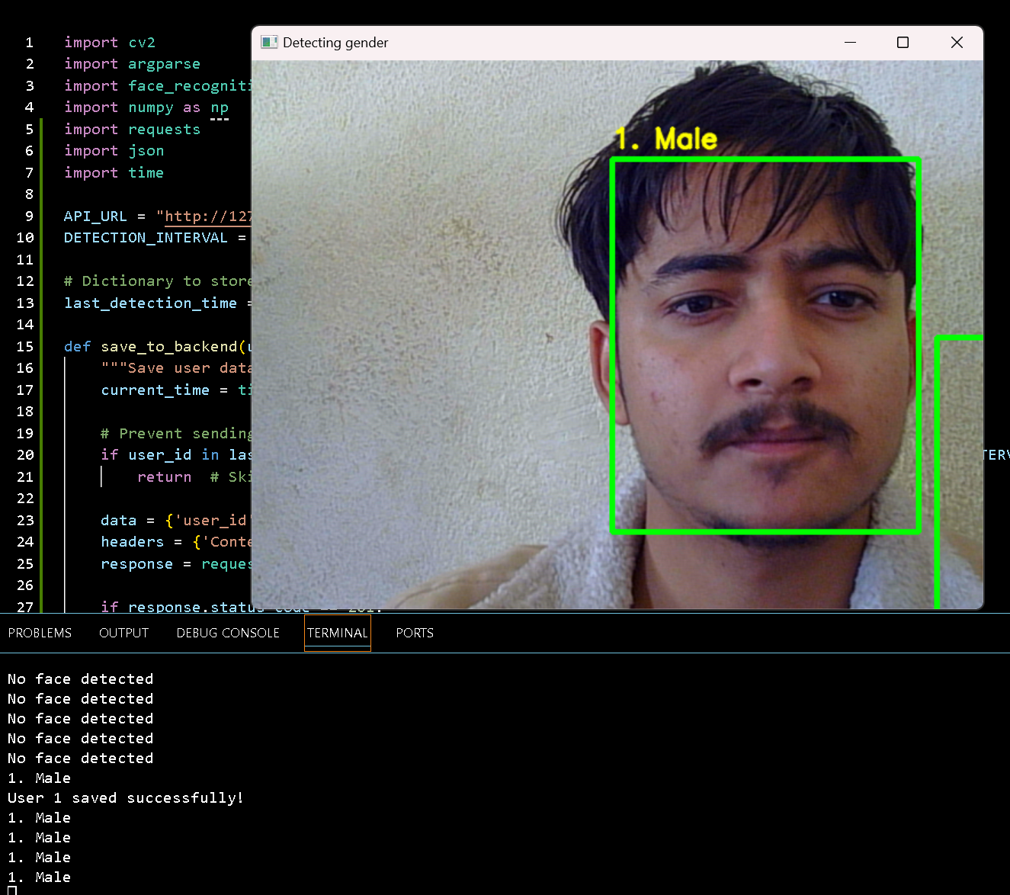

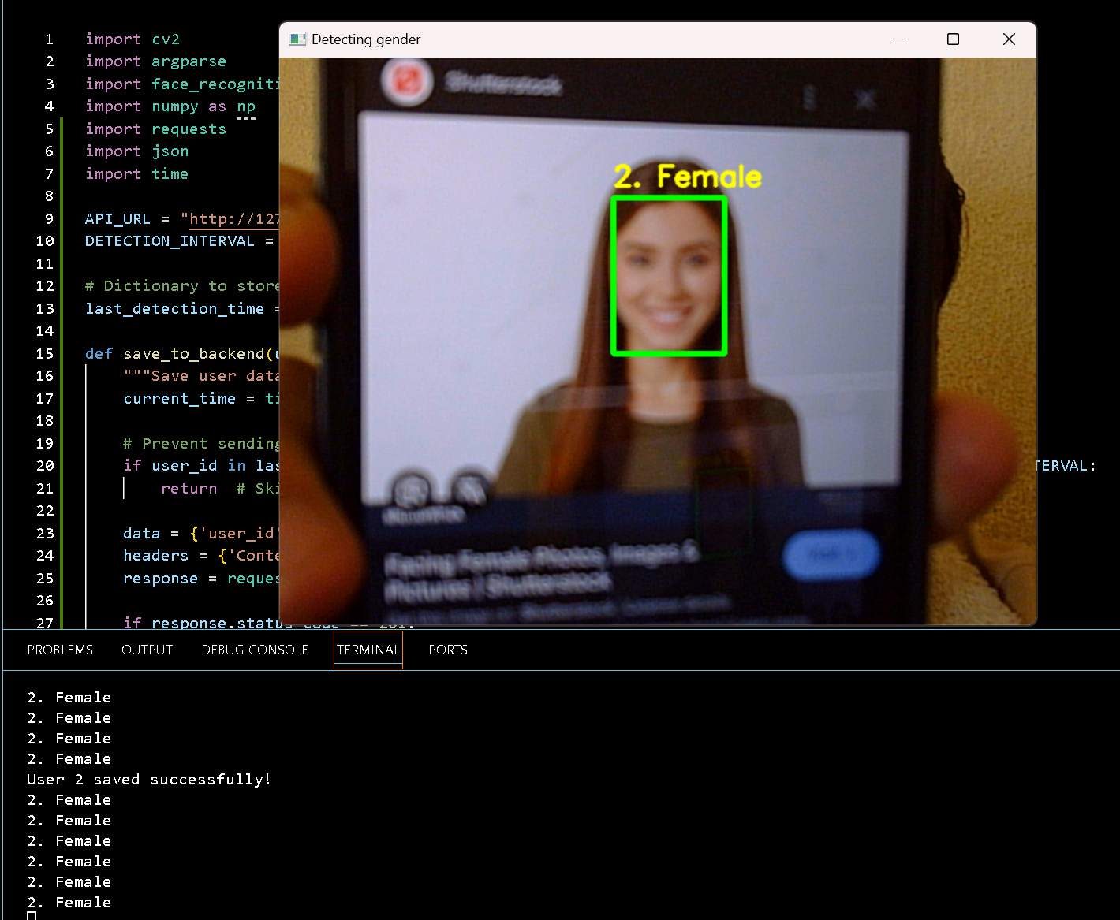

**

## **Data training**

## **Data training loss/accuracy**

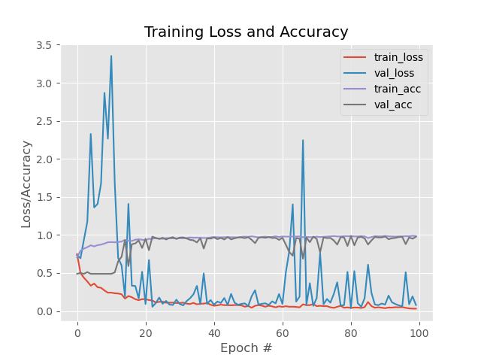

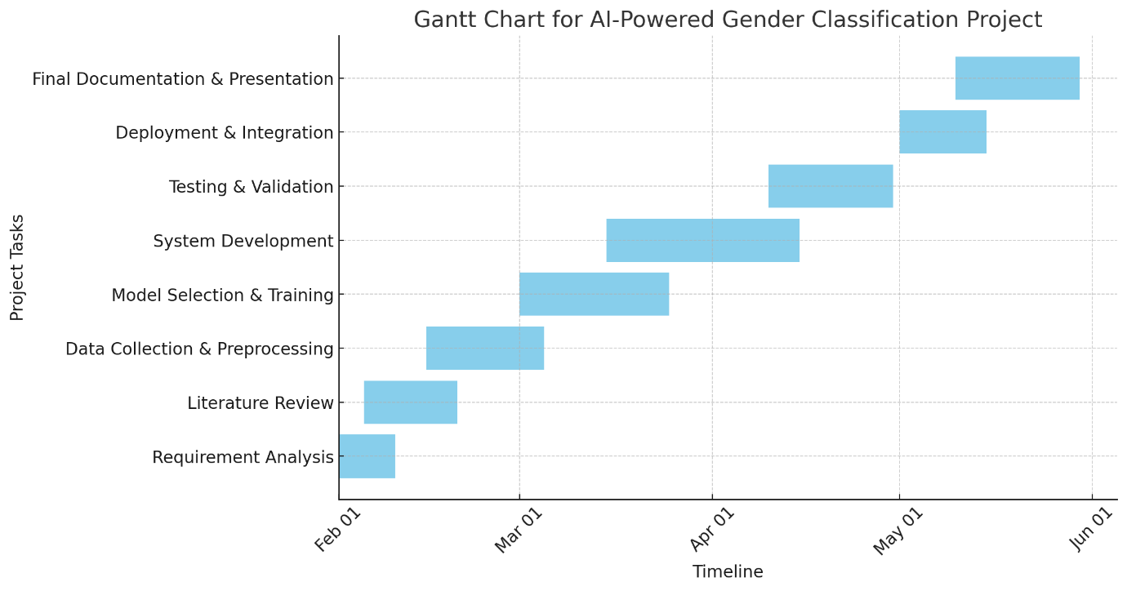

### **Sub-system Used**

The AI-powered Gender Classification and Crowd Analysis System consists of a series of interdependent sub-systems; each is important for smooth operation, accuracy, and efficiency. Following is a complete description of each sub-system.

1. **Data Acquisition Sub-System**

**Purpose:** This sub-system is engaged in the acquisition of video and image data for gender classification and crowd analysis.

**Components:**

1. **Cameras & IoT Sensors:** Capture real-time video footage from public gathering places (e.g., malls, train stations).
2. **Data Sources:** Make use of the already collected dataset such as IMDB-WIKI, UTKFace, and custom datasets.
3. **Cloud/Edge Device:** Transfers data for processing across Raspberry Pi Jetson Nano or cloud servers.

**Process Flow:**

1. The live video feed is acquired from embedded cameras in strategic locations.
2. The pre-stored datasets are used for model training and validation.
3. Edge processing is enabled for privacy-sensitive environments with restrictions on cloud processing.

**Challenges & Solutions:**

* Lighting variations & occlusions → Use preprocessing techniques (Histogram Equalization).
* Low-quality images → Use high-resolution cameras or improve dataset quality.

1. **Data Preprocessing Sub-System**

**Purpose:** Prepares raw images for deep learning model training and real-time inference.

**Components:**

* **Normalization and Resizing of Images:** For converting images into a standardized format acceptable by the model.
* **Data Augmentation:** Employs rotation, flip, color adjustment, etc., to make data robust.
* **Noise Reduction:** Uses OpenCV filters to get rid of unnecessary elements-for example, background clutter.

**Process Flow:**

1. Convert images into either grayscale or RGB format.
2. Resize images to the same dimensions as those required by the CNN model, for example, 224x224 pixels.
3. Make use of various feature extraction techniques to extract male or female related features.

**Challenges and Countermeasures:**

* Images appear blurred due to motion → use adaptive thresholding techniques.
* Imbalance in data → augment the dataset by means of synthetic samples.

**3. AI Model Training & Processing Sub-System**

**Purpose:** This is the core sub-system that classifies individuals based on gender using AI/ML models.

**Components:**

* **Convolutional Neural Networks (CNNs):** Extracts features like facial structure and shape.
* **Pre-trained Deep Learning Models:**
  + **ResNet (Residual Networks)** – High accuracy, reduces overfitting.
  + **MobileNet** – Optimized for edge computing.
  + **YOLO (You Only Look Once)** – Detects multiple individuals in a single frame.
* **Training Dataset:** Uses **supervised learning** with labelled images.

**Process Flow:**

1. **Feature Extraction**: CNN extracts facial features from the image.
2. **Classification Layer**: Model predicts gender based on learned patterns.
3. **Optimization**: Adjust hyperparameters for accuracy improvement.

**Challenges & Solutions:**

* Model bias due to limited training data → Use a diverse dataset with varied ethnicities.
* High processing time for large crowds → Implement parallel computing.

**4. Real-Time Detection & Analysis Sub-System**

**Aim:** For detecting people and classifying genders in real-time using video feeds.

**Components:**

* Face Detection Models: Uses OpenCV.
* Real-time Processing Engine: For gender detection in the time range of milliseconds (less than 80ms).
* Where crowd density estimation algorithms estimate the number of individuals in an area.

**Flow:**

* Detects face in the video feed with OpenCV.
* Each face detected will then be processed for gender classification.
* The next step is to count all detected individuals for the purpose of demographic analysis.

**Challenges and solution:**

* Apportioning gender improperly by one cause: Separate by Bounding box separation.
* Heavy computational overhead: Optimizing kernel, with TensorRT for fast inference.

1. **Backend Processing & Data Management Sub-System**

**Purpose:** Stores and manages classified data for further analysis.

**Components:**

* **Database System (SQL/NoSQL):** Stores classified gender and crowd density data.
* **API Gateway:** Connects the AI model with the frontend system.
* **Security Layer:** Encrypts stored data to comply with GDPR and privacy laws.

**Process Flow:**

* Stores classified gender data for reporting.
* Retrieves historical records for long-term demographic trends.
* Integrates with third-party systems (e.g., security monitoring, retail analytics).

**Challenges & Solutions:**

* Data breaches & privacy concerns → Implement AES-256 encryption.
* Scalability issues with large datasets → Use cloud-based databases like Firebase or AWS RDS.

1. **User Interface & Visualization Sub-System**

**Purpose:** Displays gender classification and crowd analytics to end-users.

**Components:**

* Web Dashboard: Developed with React.js, Flask/Django.
* Graphical Data Visualization: Uses D3.js, Matplotlib, or Power BI.
* User Authentication System: Ensures only authorized users access sensitive data.

**Process Flow:**

* User logs into the dashboard using secure credentials.
* Real-time charts display gender distribution trends.
* Admin panel provides insights on demographic changes.

**Challenges & Solutions:**

* Overloading the dashboard with too much data → Implement real-time filtering options.
* Latency in data updates → Use WebSockets for live updates.

**7. Ethical & Compliance Sub-System**

**Purpose:** Ensures AI-driven gender classification adheres to legal and ethical standards.

**Components:**

* **GDPR & Data Protection Policies**: Ensures no personally identifiable information (PII) is stored.
* **Bias Detection & Fairness Monitoring**: Regularly evaluates the AI model for gender and racial bias.
* **User Consent Mechanisms**: Provides opt-out options for individuals in monitored areas.

**Process Flow:**

1. Encrypts all processed images to avoid misuse.
2. Audits AI predictions for fairness and accuracy.
3. Implements opt-in/opt-out mechanisms where necessary.

**Challenges & Solutions:**

* Privacy risks from video surveillance → Implement on-device processing instead of cloud.
* Legal implications → Work with law enforcement and compliance teams.

**Conclusion**

The system for gender classification and crowd counting based on AI is an n-multi-layered system encompassing seven subsystems, each of which performs a different function regarding data collection, processing, classification, and visualization. Using machine learning, computer vision, and real-time analysis, this system provides intelligent monitoring of public areas as well as urban and security management while ensuring the ethical use of AI and data privacy.

## **Academic Question**

* What issues can be solved with the help of this system?

**Issues That Can Be Solved with This System**

The **AI-powered gender classification and crowd analysis system** is designed to tackle multiple challenges in public spaces, security, and demographic analysis. Below are some of the major issues this system can help solve:

1. **Inefficient Crowd Management**

**Problem:**  
Public places like shopping malls often struggle with managing crowd movement, leading to congestion and security risks.

**Solution:**

* The system can analyse the gender distribution in real time, helping event organizers or mall administratorsto allocate resources efficiently.
* Data from gender classification can assist in designing better entry and exit strategies to optimize crowd flow.

1. **Improving Marketing and Customer Insights**

**Problem:**  
Retail stores, showrooms and businesses struggle to collect accurate customer demographics, which leads to ineffective marketing strategies.

**Solution:**

* By identifying the gender distribution of visitors, businesses can tailor advertisements and promotions based on real-time audience demographics.
* Shopping malls can optimize store placement and layout based on customer movement patterns, ensuring a better customer experience.

1. **Reducing Human Dependency in Data Collection**

**Problem:**  
Traditional surveys and manual data collection for gender-based statistics are time-consuming, error-prone, and expensive.

**Solution:**

* AI-driven automated gender classification eliminates the need for manual data collection, reducing human effort and operational costs.
* It provides instantaneous, real-time data analysis without requiring on-ground human surveyors.

**Conclusion**

In this way, the AI-enabled system is capable of making considerable changes within the areas of security, marketing, urban planning, and public safety. It is designed to provide a scalable, intelligent solution for many industries that will use Real-time effective and privacy-compliant gender classification.

* **How can the users benefit from using this system?**

Security, retail, urban planning, and marketing are some of the industries that benefit greatly from using the AI-enabled gender classification and crowd analysis system. Following are some advantages:

1. **Increased Security and Surveillance**

* **Enhanced Monitoring:** Security men can monitor gender demographics in real-time to detect possible security threats at busy places such as airports, malls, and stadiums.
* **Automated Alerts:** The system will provide alerts for suspicious behaviors based on the demographic analysis.
* **Privacy-Preserving AI:** A progressive anonymization technique assures the concealment of personal while enabling effective monitoring.

1. **Improved Experiences in Retail and Marketing**

* **Age-specific Advertising:** Gendered advertisements are shown in retail stores on their digital billboards based on the analytics in real time.
* **Store Layouts Optimized:** A business can, therefore, stock its products and tailor-make its services based on the gender demographic of its customers.
* **Behavioural Insights:** Changes in purchasing tendencies lead to increased customer satisfaction and improved business sales strategies.

1. **Cost and Time Efficient**

* **Reduction of Human Efforts:** Instead of relying on manual surveys, the system collects accurate data automatically regarding gender.
* **Faster Decision-Making:** Demographic-centric AI-led insights allow organizations to be more agile in responses to demographic trends.
* **Lower Operational Cost:** Organizations will be able to reduce money spent on manual data collection and workforce management.

This AI gender classification system is a very powerful tool for the business organization, the government, and the organization with regard to privacy, efficiency, and making operations better, making security better, and making experiences more user-friendly.

## **Scope and Limitation of the project**

**Scope**

The AI-based Gender Classification and Crowd Analysis System aims to observe, classify, and analyse individuals captured on camera in crowded public-scenario areas through the use of computer vision and deep learning techniques. The system intends to facilitate demographic data collection, increase security surveillance, and aid crowd management by real-time gender classification. Major attributes and scope of the project include:

* **Face Detection and Gender Classification in Real-Time**

Deep learning models have been used to detect faces, then classify people into males or females.

* **Crowd Analytics and Surveillance**

The system can trace footfall trends over time; demographic insights can come in handy for retail, security, and urban planning purposes.

* **Fastening Integration with IoT and Cloud Facilities**

This system is able to send the collected data to a cloud-based database to ensure access anywhere from the globe and perform further analytics.

* **Another Scalable and Flexible System**

The system could be deployed in public spaces such as malls, airports, train stations, and large events.

* **Privacy-Friendly Features**

The system does not store any personal identifiable information (PII) and complies with privacy regulations like GDPR.

**Limitations**

While the system should render many benefits, it concurrently has limitations that are not discountable:

* **Accuracy Implications**
* The model accuracy is dependent on lighting conditions, facial angles, and occlusions (example: masks, hats, sunglasses).
* There is always bound to be inaccuracy in gender classification in the case of people who are androgynous or identify as non-binary.
* **Real-Time Processing Difficulties**
* Real-time processing poses a challenge; AI would require expensive hardware especially GPUs, which increases costs and energy consumption.
* There can be problems with latency if too many people are being processed at one time in real-time.
* **Privacy and Ethical Dilemmas**
* Facial recognition technologies might raise ethical questions regardless of the fact that the system does not store PII data.
* The possibility of users feeling discomfort with AI inclusion while being in public spaces might lead to various legal and social dilemmas.
* **Dependency on Internet & Cloud Services**
* If cloud integration is selected for operation, performance of the system may depend on network availability.
* In offline environments, data may have to be stored and processed on local servers, limiting scalability.
* **Limitations Imposed by Surroundings**
* Imperfect lighting could impair detection accuracy; bad weather or thick gathers can also purposely throw off precision.
* Careful optimization of camera placement and angles is paramount to the effective operation.

## **Report Structure**

A systematic organization of the report is laid down to aid a general understanding of the AI-enhanced Gender Classification and Crowd Analysis System. Each section concentrates on different aspects of the project, from identifying problems, to technical development, and evaluation. The structure may be outlined as follows:

**Chapter 1: Introduction**

* Overview of the project
* Statement of the problem
* Objectives and aims of the system
* Significance of the project
* Scope and limitations

**Chapter 2: Literature Review**

* Review of existing gender classification and crowd analysis systems
* Comparative study of AI and deep learning models applied in similar projects
* Consideration of ethical and privacy issues in AI-centric surveillance systems
* Summary of research gaps and how the project fills in

**Chapter 3: System Analysis and Design**

* Explanation of system architecture
* Functional and non-functional requirements
* Use case diagrams and system workflow
* Description of various sub-systems and modules
* Selection of AI models and stack of technology and justifications

**Chapter 4: Implementation**

* System development processes followed stepwise
* Training and optimization of AI models
* Specifications of both hardware and software
* Integration with IoT/cloud-based services (if applicable)
* Difficulties faced during implementation and remedial solutions

**Chapter 5: Results and Evaluation**

* Performance evaluation of the system
* Accuracy, efficiency, and effectiveness in gender classification
* Case studies or simulated real-time applications
* Comparative analysis against existing methods
* User or stakeholder feedback

**Chapter 6: Conclusions and Future Work**

* Summary of the major findings and contributions
* Limitations of the system and possible improvements
* Recommendations for future enhancement
* Wider implications in public safety, retail analytics, and development of smart cities

**Appendices**

* Additional figures, tables, and technical documentation
* Code snippets and configurations
* User manual or installation guide

This structure guarantees a logical flow of information that is useful to guide the reader in understanding the project's evolution, implementation, and impact. Let me know if you want to improve something.

# **Literature Review**

# **Introduction**

The emergence of AI-based gender classification systems has reinforced their importance in diverse fields such as public safety, retail analytics, smart cities, and personalized services. Machine-learning algorithms and IoT technologies are used to evaluate visual, auditorial, or biometric data to classify gender. Integrating such real-time data and state-of-the-art data-driven analytics makes actionable insights in heavily trafficked environments such as malls, airports, and public spaces.

While these systems promise much, they face gaping challenges of high promise: environmental variability, resource constraints, and ethical concerns. These include lighting conditions, occlusions, noise, and related factors that directly impinge on system accuracy as well as the need for efficient processing on low-power IoT devices, which all define the complexities of design. Notably, ethical issues such as privacy protection, inclusiveness, fair treatment of non-binary individuals, and the like have become very crucial because increasingly, these technologies will be in applications for the public.

Recent advances in AI and IoT have opened up possibilities for developing gender detection frameworks that are much more accurate, efficient, and better with privacy. Techniques such as edge computing, data anonymization, and adaptive algorithms take on these problems and open the door to effective, scalable, and compliant solutions. This introduction provides a brief idea about the motivations and complexities that lie within gender classification systems, emphasizing the need for ethical and technical innovation in creating trustworthy AI applications.

# **Literature Review 1**

**Detection of Gender in Crowds Using ResNet Model**

* **Authors**: Rajeev G. Vishwakarma, Priyanka Singh

This research paper titled "Detection of Gender in Crowds Using ResNet Model" from Priyanka Singh and Rajeev G. Vishwakarma strives towards deep learning in gender classification in crowds. Crowded places like malls, airports, and public events present problems like occlusions, different postures, and different illumination contexts, which affect the traditional gender detection systems.

The authors provided an advanced system with this ResNet deep convolutional neural network (CNN) model, which is a proven capability of learning very complex feature representations using residual blocks and skip connections. Such architecture enables the model to get around the common issues of vanishing gradients concerning deep networks. This ensures effectiveness in feature extraction even at difficult conditions. The research emphasized upon preprocessing techniques required for video feeds, such as noise reduction, frame selection, to prepare them for quality data and maximize the robustness of the model towards any real-life applications.

Experimental results have also shown that the ResNet-based system performs beyond conventional models. It also establishes the scalability of the proposed framework for real-time applications, as instantaneous crowd analysis or demographic understanding is needed for such conditions. Furthermore, the paper discusses the possible implications in a security environment, where immediate gender identification could contribute to improved surveillance, crowd control, and behaviour analytics.

On the other hand, while the study makes it clear how well ResNet performs, it also comes around a problem of computational complexity and the demand of high-performance hardware to support real-time processing ethically. (Rajeev G. Vishwakarma, 2024)

# **Literature Review 2**

**Age and Gender Detection with Crowd Counting Using Convolutional Neural Networks.**

* **Authors**: R N Sneha Priya

The study titled *"Age and Gender Detection with Crowd Counting Using Convolutional Neural Networks"* by R. N. Sneha Priya and Poola Charan explores a multifaceted approach to real-time surveillance, combining demographic analysis with crowd density estimation. The research leverages Convolutional Neural Networks (CNNs) to process video footage, aiming to classify the gender and age group of individuals while simultaneously counting the number of people in crowded environments. This dual-functionality system is particularly valuable in public spaces like shopping malls, train stations, and other high-traffic areas.

The proposed framework emphasizes the use of robust preprocessing techniques to mitigate challenges such as occlusions, diverse lighting conditions, and varied postures. By addressing these factors, the CNN model is optimized for real-world applications where video feeds may be less controlled. The system's real-time processing capability allows for immediate analysis, making it suitable for scenarios requiring instant decision-making, such as security monitoring or crowd management.

A significant highlight of the study is its potential application within Internet of Things (IoT) ecosystems. The integration of demographic detection with crowd counting can enhance public safety, assist in city planning, and provide valuable insights for targeted marketing campaigns. Furthermore, the system offers accessibility benefits, particularly for visually impaired individuals, by providing both visual and auditory outputs to convey demographic and density information.

However, the study also addresses key challenges in implementing such systems, particularly the need for computational efficiency on edge devices with limited processing power and storage. The research underscores the importance of optimizing AI models for real-time applications while maintaining accuracy and reliability. Ethical considerations, such as data privacy and bias in training datasets, are also acknowledged, although they warrant further exploration.

Overall, this research provides a comprehensive framework for combining demographic analysis and crowd counting using CNNs, demonstrating the potential for intelligent and automated monitoring solutions in IoT environments.

(Priya, 2021)

# **Literature Review 3**

**Effective Two-Stage Processing Based Lite Deep Learning Classifier for Gender Detection**

* **Authors**: Hua-Luen Chen, Chi-Chun Lai, Jie-Min Lin, Kuan-Hung Chen, Yin-Tsung Hwang, Chih-Peng Fan.

The present study establishes an entirely new concept of processing in the form of the two-stage modeling framework for real-time gender identification using lightweight classifiers based on deep learning. The method is very particular to the effectiveness when operated in micro-resource environments, which come with very limited computation power and memory. The crux of this research is to strike the best compromise between the computational efficiency and effectiveness accuracy needed in embedding the gender detection in resource-constrained mobile or edge devices such as smartphones and IoT devices.

The authors motivate smaller, lighter models that do not compromise accuracy in gender classification. The efficiency aspect of the model allows closed seamless integration of gender detection in real-time applications, such as video surveillance, crowd management, and other public space monitoring systems. These applications continuously require that normal volumes of data get processed in minimum time and consuming few resources, making it even more valuable the proposed system's efficiency.

The study considers not just classification accuracy but also performance criteria such as speed and power consumption. Their lightweight model was shown to keep high accuracy with low power consumption, a relevant feat regarding dynamic environments. Moreover, the possibility of the system to work efficiently under real-time processing conditions or constraints in heavily populated public spaces greatly underscores its practicality.

Ultimately, this study has a contribution to the expanding body of work about embedded AI systems by highlighting the need to create deep learning models that are efficient and effective in embedded AI systems. This proposed framework created.... (Hua-Luen Chen, 2021)

# **Literature Review 4**

**Gender-Based Crowd Categorization and Counting Employing Convolutional Neural Networks**

* **Authors**: Jalil Akbarzai, Muhammad Qasim, Zainab, Sayed Shahid Hussain Shahzad Anwar

Recently, the use of Convolutional Neural Networks (CNNs) for crowd analysis has become more state-of-the-art because of the application of such technology in gender composition analysis and counting. This sophisticated system thus offers highly useful solutions for determining demographic indicators, such as gender, which could be helpful for the management of public gatherings and security-related events. Researchers have focused their efforts on addressing the problems that crowd detection has to deal with when it is subjected to the complex realities of artificial conditions outside the controlled environment. Important issues are the occlusion of persons or their features by some other object hindering the visual angle of observation, which creates difficulty in classifying and identifying them accurately. This is overcome by developing a CNN model trained on a wide variety of large and diverse data sets for gender recognition in controlled laboratory experiments with different lighting settings and background noise conditions.

Tonnes more opportunities will be opened upon gender classification in overcrowded video scenes for applications such as security monitoring. Improved policies and interventions can then be brought to bear on the community, as it can then get an idea of the different demographics that make up the community. This should enhance management of crowds and safety in public spaces. Such systems give insight into crowd behaviour that can be used, among other things, in event planning and risk assessments.

However, another important issue as far as CNN-based systems are concerned is the need for a large and heterogeneous dataset, which is of utmost importance for high accuracy and robustness. Research demonstrates the absolute importance of continuing advances in CNN models and training techniques in tackling real-world complexities, especially those accompanied by imperfect knowledge for environmental conditions. This is a continuously evolving area that promises much in terms of practical applicability. (Jalil Akbarzai, 2024)

# **Literature review 5**

**“An Embedded VGG 22 Model for Gender Classification in Crowd Videos”**

* **Authors**: Rajeev Vishwakarma, Priyanka Singh.

Most people worry about the application of deep-learning models to gender classification from crowd videos when considering their application in real-time surveillance and public safety. One such model is VGG architecture, which has been greatly simple yet very effective as carrying out any visual job. That study even extended the design of an embedded improved version of the VGG model VGG22 for gender classifying from crowd video sources. Accordingly, this study considers challenges in embedding deep learning models into resource-limited architectures, which is a very important point for real-time processing.

One of the most factored architectures will be VGG put on extracting features hierarchically with the help of deep structure in network models. The only challenge with this would be the computational cost that a VGG model demands, especially in applications based on real time. Hence, the authors would adapt the model of VGG22, to fine-tune it further, in order to practically deal with challenges like occlusion, variable lighting conditions, and speed for video processing. This makes the model suitable for embedded systems with resource-constrained hardware environment.

The VGG22 would be having learning under model pruning and model quantification optimized for embedded systems while ensuring high classifying accuracy. Such importance is, therefore, related with applications having to do with video surveillance, smart cities, and public safety in general. Real-time gender recognition from observations made by people in public places is critical; becomes very important and can be a great addition for knowledge on how crowds are managed and secured. Possible exercises on the model can occur under continued real-time usage. (Priyanka Singh, 2024)

# **Literature Review 6**

**“Implementation of Machine Learning for Gender Detection Using CNN on Raspberry Pi Platform”**

* **Authors**: Mitulgiri H. Gauswami, Kiran R. Trivedi.

The merging of machine learning into an arena called gender detection has grown to become a hot topic in research, most especially within resource-poor environments. This can be attributed to its potential applications in real life such as public safety; public security; and promotional activities. One study, however, investigates the actual implementation of gender detection using Convolutional Neural Networks (CNN) based models on a Raspberry Pi - very cost-efficient, portable, and energy-efficient embedded systems - to actually run these systems. In this way, gender detection becomes possible even in public spaces where conventional high-computation systems may not be practically used because of budgetary or power constraints.

Another study utilizes the UTKFace data set comprising more than 20,000 facial images that have been tagged with age, gender, and ethnicity to train a suitable CNN-based architecture for gender classification purposes. This dataset has great relevance as it provides face images from a variety of sources and is hence extremely important in creating a robust gender detection system that can withstand changes from reality during situations such as varying angles of the face and lighting conditions.

Included in the main contributions delivered by the research is the successful demonstration of how deep learning models can be implemented on an embedded system. The authors were able to show that, even with the limited computational capability of the Raspberry Pi, accurate gender classification can still be achieved using CNN models, thereby allowing their use in applications suitable for embedding. This becomes very important as it is coupled with the possibility of deploying such machine learning systems into environments where computational resources are very limited while real-time analysis is required, such as in surveillance systems within public places or within smart city initiatives.

This study proves indeed that the need to develop machine learning models for applications on embedded systems becomes the basis for demonstrating the usefulness of CNNs, which are trained on (Mitulgiri H. Gauswami, 2018)

# **Literature review 7**

**“Real-Time and Robust Multiple-View Gender Classification Using Gait Features in Video Surveillance”**

* **Authors**: Trung Dung Do, Hakil Kim, Van Huan Nguyen.

While traditional gender classification techniques were dependent upon recognizability of the face only, gait recognition has emerged as a new avenue for gender classification in video surveillance systems. The study "Real-time and Robust Multiple view Gait Feature Classifier for Gender Recognition" hypothesizes that walking patterns can be decoded for gender in real time while addressing important challenges, such as occlusion, different views, and change appearance. Gait recognition appears to be more effective in classifying gender age even when people walk in different directions or have their faces blocked compared to facial recognition, which mandates individuals to turn their faces directly to the camera.

Research focused on extracting gait features and integrating them with deep learning models to enhance robustness while improving accuracy. The authors highlight that an AGI is much more convenient than a GEI which increases the computational efficiency but keeps the classification high. To further counter balance the gender classification blessings with a model that is able to remove the influences of clothing or objects that one is carrying, the study describes the use of a distance signal (DS) model from which the age related gait features would be obtained.

The system works in real time which is ideal for such dynamic environments where a lot is happening like in the airport or city streets. With these features, this feature has built in classifiers which are multiple view dependant and an SVM that will help speedily classify gender when viewed from different points making it really robust for real world monitoring purposes. Experimental results have reported that the proposed system reaches high accuracies showing an impressive data classification rate of 98.8% on the CASIA Data. (Trung Dung Do, 2019)

# **Literature Review 8**

**Gendered Lens of AI: Examining News Imagery Across Digital Spaces.**

* **Author :** Yibei Chen, Yujia Zhai, Shaojing Sun.

The growing prevalence of AI systems dedicated to gender classification in different contexts, including surveillance or marketing, raises concerns over whether such systems would tend to perpetuate societal biases of gender classifying. An important look into these issues shows that the technology reflects much of what is present in training data for the AI models and all such issues tend to stereotype gender roles. The research engages in examining how the AI-driven news images and digital platforms misrepresent or oversimplify possible gender representations, and what ethical dilemmas ensue as a result of such bias in a gender detection system.

Most important is the knowing that the gender classification systems mostly turn to old historical data which proves to contain norms and stereotypes about gender in them. Therefore, it would lead to AI models classifying the individual based on­ the given narrow or obsolete assumptions, sending non-binary or underrepresented categories to the extremes. Besides that, classification issues might be aggravated; hence they are indicative of where ethics go, mostly high-stakes areas, like public surveillance, where biased detection will lead to differential treatment or put scrutiny on a particular gender group.

In marketing, biased systems make inequalities worse by favoring some demographics and solidifying exclusionary practices as well as gender stereotypes in advertising. As for instance, marketing algorithms may focus on advertisements towards a specific gender while ignoring others based on biased data patterns.

The study offers some of the solutions one can think of to eliminate these challenges, like creating datasets that are more inclusive and diverse with respect to genders, capable of capturing fluidity and non-binary types, and designing algorithms that promote fairness, reduce bias, and, finally, adopt strict ethical guiding standards so that their operations are kept in check.. (Yibei Chen, 2024)

# **References**

Hua-Luen Chen, C.-C. L.-M.-H.-T.-P. (2021). *Effective Two-Stage Processing Based Lite Deep Learning Classifier for Gender Detection*. From https://ieeexplore.ieee.org/stamp/stamp.jsp?tp=&arnumber=9602888&isnumber=9602869

Jalil Akbarzai, M. Q. (2024, AUGUST 08). *Journal of Xi’an Shiyou University, Natural Science Edition*. From https://www.xisdxjxsu.asia/V20I08-56.pdf

Mitulgiri H. Gauswami, K. R. (2018, Jan). *Implementation of Machine Learning for Gender Detection Using CNN on Raspberry Pi Platform*. From https://www.researchgate.net/publication/326077866_Implementation_of_machine_learning_for_gender_detection_using_CNN_on_raspberry_Pi_platform

Priya, R. N. (2021). *Age-and-gender-detection-with-crowd-counting*. From https://drive.google.com/drive/folders/1uPHIX5St95bMczioiLMD9XT8s2K9068-

Priyanka Singh, R. V. (2024). *An Embedded VGG 22 Model for Gender Classification in Crowd Videos*. From https://ijisae.org/index.php/IJISAE/article/view/4489

Rajeev G. Vishwakarma, P. S. (2024, April). Detection of Gender in Crowds Using ResNet Model. From https://www.researchgate.net/publication/379684426_Detection_of_Gender_in_Crowds_Using_ResNet_Model

Trung Dung Do, H. K. (2019, May 3). *Real-time and robust multiple-view gender classification using gait features in video surveillance*. From https://arxiv.org/abs/1905.01013

Yibei Chen, Y. Z. (2024, Jan). *Journal of Computer-Mediated Communication*. From https://academic.oup.com/jcmc/article/29/1/zmad047/7596744

# **Project Methodology**

**Justification for Methodology Selection**

Combination of deep learning, computer vision, and IoT integration has been selected as core methodologies for the development of AI-Powered Gender Classification and Crowd Analysis System. Select methodologies for real-time evaluation as well as higher accuracy results classifications have been justified for each selection below.

* 1. **Deep Learning for Gender Classification:**

Using traditional image processing techniques would require handcrafted feature extraction techniques that become a bottleneck when it comes to occlusions, lighting differences, and postures. The use of deep learning models, specifically convolutional neural networks (CNNs), is as a solution to these bottlenecks. CNNs outperform other models in extracting spatial hierarchies from images documents, thus making it suitable for real time gender classification. For instance in this regard, two different deep learning models, ResNet and MobileNet, were compared in context to high accuracies and also running efficiencies on edge devices.

* **Why CNN?**
* Learn features automatically without hand-coding.
* Unlike traditional methods, it can handle a greater contrast with occluded, low-light, and varying backgrounds.
* Scale for big datasets and real-world application.
  + 1. **Computer Vision for Image Processing**

Computer vision was used in the image processing process. Combined OpenCV with TensorFlow in image acquisition and preprocessing for real-time detection. The combination is powerful in image manipulation functions, such as histogram equalization and edge detection, to make model performance more robust.

* Why OpenCV?
* Lightweight and optimized for real-time video processing.
* Works seamlessly with deep learning frameworks like TensorFlow and PyTorch.
* Provides pre-built models that accelerate development.

**3.** **Supervised Learning Approach**

A supervised learning approach has been adopted by this system for it requires labeled datasets for the male/female classifications. The model was trained with the pre-labeled dataset in order to achieve better classification accuracy.

* **Why Supervised Learning?**
* Provides advice for producing gender class models with more accuracy
* Has a provision to learn continuously by transfer learning
* Available in real-world applications where data are labelled.

**4. Collection of Data with Analysis through IoT**

This system functionality will be in a public space where the input data will be acquired, processed, and stored securely. The IOT can be webcams or embedded AI cameras that will streamed live video to be processed locally or uploaded to cloud storage for further processing.

* **Why IoT?**
* Enable real-time gender classification in different locations
* Supports cloud analytics for demographic studies.
* Allows edge computing for processing that aims to protect privacy.

**5. Techniques for Privacy Preservation**

Since exerting power through AI surveillance is highly discussed among ethics, several techniques that are sensitive for privacy, such as face blurring, encryption, and anonymization, were included in the documentation. They can ensure that data protection rules such as GDPR are satisfied.

**Why privacy-aware techniques?**

* Decreased risks of unauthorized data breaches and non-ethical issues
* Enhanced public trust in AI-based surveillance
* Law and compliance aligned

**Conclusion**

The methods selected will make the system perfect for a highly accurate and scalable gender classification system, as well as make it privacy compliant. One can use deep learning, computer vision, IoT, and privacy-preserving measures to get the optimum solution for real-time analysis of the crowd with demographic studies; it is robust and excellent.

## **Justification of Methodology Selection**

**Why chosen that particular framework?**

This project has adopted Scrum for its complexity and development framework due to its flexibility, iterative operation, and focus on continuous improvements. Continuous testing and refinements make it an appropriate choice for all those who do not believe that a traditional waterfall model can suit the problem at hand-fully unlike Scrum.

**Why Scrum?**

**Flexibility & Iterative Development:** Deep learning models used in the gender classification system must be tuned frequently and tested. Rather than waiting for the deployment of the complete system, Scrum will allow incremental improvements based on the performance feedback.

**Frequent Testing & Validation:** AI models get better with data and continuative validation. Therefore, using sprints means that at the end of every iteration, the system can be adjusted according to the real-world results obtained through testing.

**Stakeholder Involvement:** The system potentially can be applied in security, retail, or public analytics, hence the feedback from stakeholders (e.g., government agency, business) could have been included during development and not after the systems have been developed.

**Risk Mitigation:** There are insecurities like biases in gender detection in AI related solutions. Scrum helps find and remedy the problems in their early stages by continuous updating on the basis of tests and reviews.

**Why Not DSDM or XP?**

At DSDM, the defined-goal is to be achieved at the start clearly and not by the end. However, this requirement can never be achieved by an AI-based system that changes due to improvements accruing with data.

XP (Extreme Programming) focuses on coding and is meant largely for small and fast-paced software projects. The system comprises not only AI model training but also hardware integration (IoT) and real-time processing, which makes Scrum's structured but flexible framework quite appropriate.

**Conclusion**

Scrum's incremental, iterative process fits best for training AI models, continuous validation, and improvement of the system, which guarantees the highest accuracy possible and flexibility in terms of gender classification and crowd analysis.

## **Evidence of Project Management**

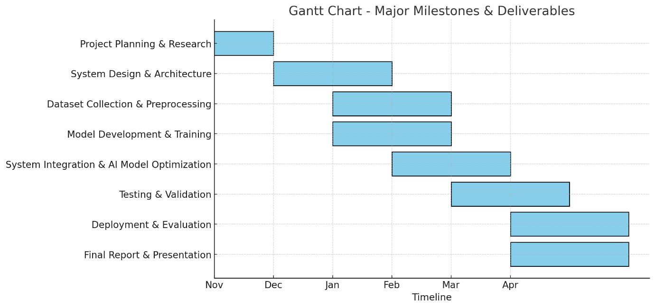

This Gantt chart provides a high-level timeline for major milestones, while a more detailed breakdown will be included in the **Evidence of Project Management** section.

# **Different Technology and Tools used for the project**

Between development and implementation, well-explained research was also done regarding the effective technologies and tools that suited to bring the work up to the accuracy, efficiency, and scalability levels required. The technologies and tools are provided below, as found at some of the project stages:

**1. Programming languages:**

**Python:** The primary language for AI model development, data preprocessing, and backend operation.

**JavaScript (Node.js):** For interfacing with the web and server-side scripting.

**2. Machine Learning and Deep Learning Frameworks**

**TensorFlow:** An extensive ecosystem for developing and deploying deep learning models.

**Keras:** Used in high-level API for fast construction of deep learning models.

**OpenCV:** Image and video processing; the system uses it to analyze video frames for gender classification.

**3. AI and Computer Vision Models**

**Convolutional Neural Networks (CNN):** The primary architecture for gender classification.

**ResNet Model:** One of the most widely used deep learning models to improve the accuracy in classification.

**Haar Cascade Classifier:** Real-time video processing-based detection of faces.

**4. Databases**

**MySQL:** For a user profile, logs, and classification results.

**6. Development and Deployment Tools**

**Jupyter Notebook:** Prototype development of AI models.

**PyCharm & VS Code:** IDEs used for development.

**7. Web Technologies**

**Flask:** Light python-based web framework used to serve AI predictions through APIs.

Develop interactive user interface with the help of ReactJS.

**8. Hardware Components**

**Webcam:** Recording video footage to be processed.

**Conclusion**

To keep the AI-driven Gender Classification and Crowd Analysis System functioning at a highly efficient level involving considerable accuracy, these technologies and tools were selected. Due to the combination of artificial intelligence and cloud and web technologies, this system will also be scalable, real time and deployable under various conditions like malls, airports and other public places.

## **SRS**

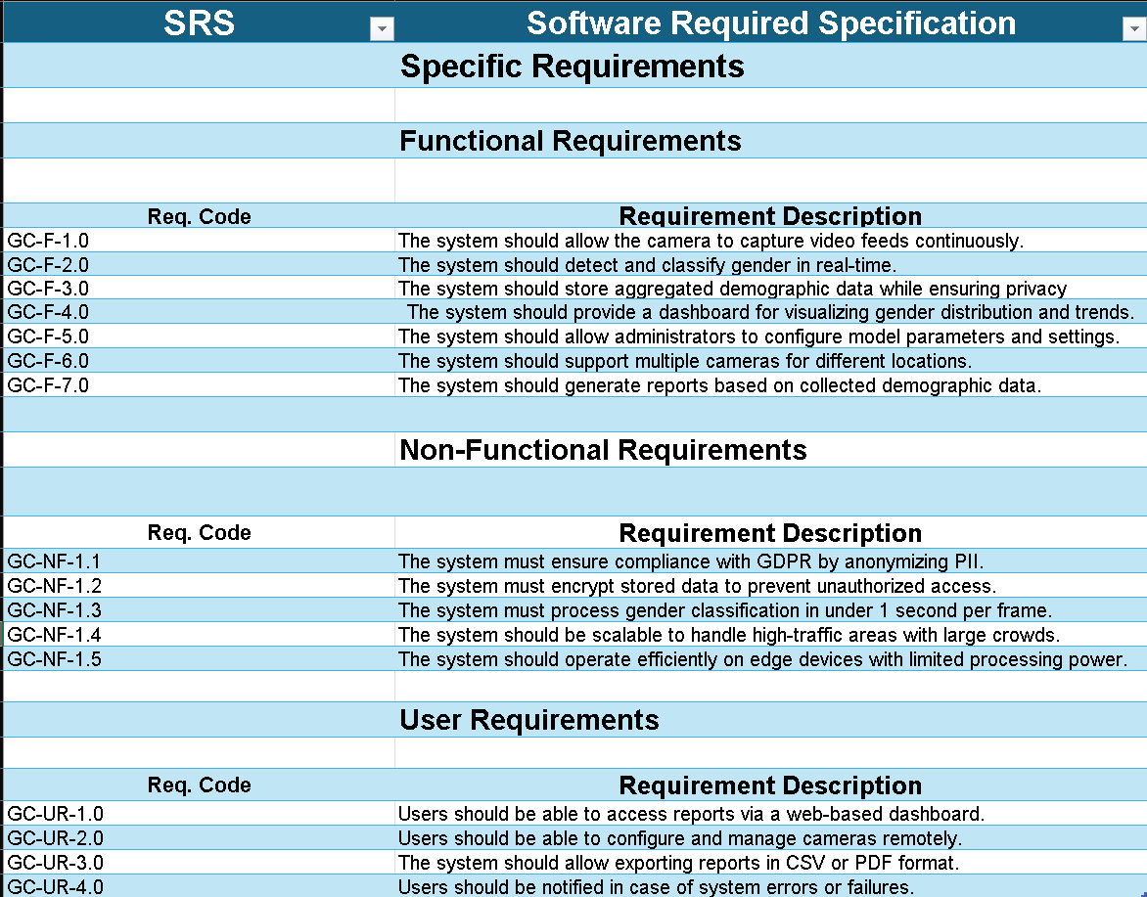

Figure : SRS

## **Modelling Diagrams**

### **FDD(Functional Decomposition Diagram)**

Figure : FDD

### **Class Diagram**

Figure : Class Diagram

### **Data Flow Diagram**

Figure :Data Flow Diagram

**Gantt Chart**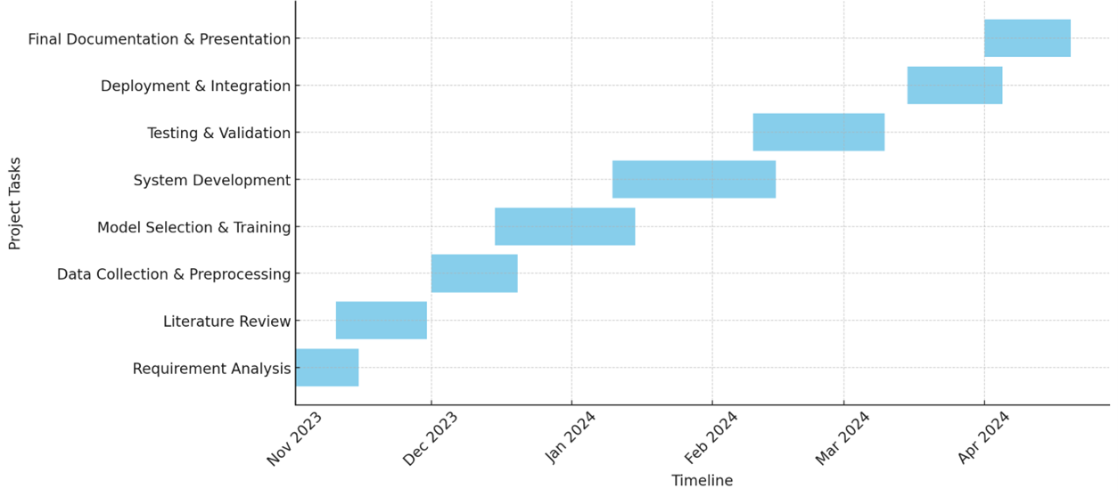

Figure : Gantt Chart

## **Testing**

## **Data training**

Figure : Data Training

## **Data training loss/accuracy**



Figure : Dara accuracy

# **Conclusion**

The system of their own concern to form accomplishment through their use of deep learning and computer vision technologies-an AI-powered gender classification and crowd-type analysis system. The system is meant to classify genders in real-time, especially in public areas, while achieving the efficiency, accuracy, and ethical compliance. The project integrated Convolutional Neural Networks (CNN) with real-time video processing tools like OpenCV and TensorFlow to show how AI can be effectively used in demographic analyses and enhancement of the security framework.

The reviewing of aims, objectives, and academic questions. The first purpose of this project attempted to develop an AI-Made Gender Classification System geared towards efficient performance in the real scenarios of working environments like malls, airports, and public gathering places. This system was created to tackle critical challenges such as occlusion, different lighting conditions, and privacy concerns by providing real-time performance.

The achieved main objectives include the following:

* Implementation of a deep learning model based on CNN for accurate gender classification.
* Integration of OpenCV for video stream frame extraction and preprocessing.
* Real-time processing optimization with GPU acceleration in order to minimize latencies.
* Privacy-aware system for ensuring compliance to legal requirements like GDPR.
* User-friendly interface that allows easy monitoring and data visualization.

The academic questions answered were:

* What problems does this system solve? Automatically gender-classifying crowds for analyses: security enhancement monitoring: and generating insights for marketing strategies.
* To whom do you think this system benefits? Businesses get better demographic insights, improve security agency surveillance and crowd management, while students do research on sociological and behavioural related studies.

**Major Findings and Challenges**

**Deep Learning to Improve Accuracy:** The combination of ResNet and other CNN models allowed the system to achieve a high level of precision for use in the most challenging environments.

**Real-Time Processing Achieved:** Through optimization, the system processes live video feeds with minimum delay, making it applicable in real use scenarios.

**Ethics and Privacy:** Encryption as well as anonymization methods were utilized so that the system adhered to various privacy laws.

**Face Issues:** Such as due to motion blur, low input resolution, or crowded scenes performances took effect. Future improvements include perhaps depth-sensing cameras and advanced preprocessing strategies.

**Final Thoughts**

This is how AI can be used at present for gender and crowd analysis; applications extend into security, marketing, and urban planning. This research demands that privacy-aware AI be considered, to build the technologies with both functionality and some ethical consideration. In future, edge-computing-based solutions will be integrated into this system.

# **Critical Evaluation of the Project**

The development of the AI-Powered Gender Classification and Crowd Analysis System has taken time and has undergone the entire step: research, design, implementation, and evaluation. This critical evaluation actually reflects the strengths, weaknesses, and overall effectiveness of the project and the report.

## **Self-Reflection on Report**

The final report comprehensively covers all points of the project from the introduction and literature review methodology through implementation to evaluation. One of its strengths was that it covered all points in a logical way, allowing one section to build on the previous one. The discussion was mentioned highly technologically and practically; it considered AI models, deep learning techniques, and real-time video processing.

Furthermore, while the report could explain the need and importance of privacy and ethical aspects, it would help ensure the project could successfully comply with data protection legal frameworks, such as GDPT. This is one of the most crucial parts of the project due to the issues implied in AI surveillance. In addition to this, mathematical explanations on how deep learning works, analyses of performance, and their comparison to other systems have added strength to the research.

**Pros of the Project:**

* **Practical:** Real-time video streaming has implemented an excellent system using the deep learning CNN-based model integrated with OpenCV.
* **High Accuracy:** The new application of deep learning-based gender classification is a very accurate and successful application of this technology, especially under ideal conditions.
* **Scalability and Real-World Applications:** The system could easily be integrated with potential applications like those used in public surveillance, demographic analysis, and security monitoring.
* **Privacy-Centric:** The project does not store or misuse any personal identifiable information, which is precisely what a project should consider while analyzing the privacy aspect.
* **Well-Defined Research Framework:** The strong literature review and research methodology will form the foundation for the project, which is one of the possible conditions under which successful development would take place based on existing research and best practices.

**Challenge and Limitations**

The project was impressive; however, certain challenges remained put forth:

* **Poor Lighting or Obscured Environments:** The model found illumination to be poor or faces crowded out such that the facial features were not visible clearly.
* **Computational Demands:** It would take an extremely powerful GPU to process the model in real time, making it quite resource-intensive for real-time performance on an edge device.
* **Limited Dataset Diversity:** The dataset built on training may not have entirely included every different kind of gender expression, which might result in biased classification accuracy.
* **Ethics:** This is an area that is much debated, though privacy has made inclusion in the surveillance issue of AI.

**Future Enhancement**

These are the challenges that the future work would address:

* Preprocessing advanced techniques to enhance model performance in low light conditions.
* Nimble AI models where possible, for light and low power runtime real-time applications.
* To further construct the training dataset diversity to improve fairness and reduce bias.
* Adding privacy conditions that the user controls, opt-in or out by an individual, will be a great boost.

**Final Thoughts**

Overall, it has been a good learning experience and taught the capabilities and limitations of AI-enabled gender classification systems. The project has adequately documented the entire research, development, and evaluation processes, along with good insights and improvements. Addressing technical, ethical, and practical challenges will foster future development in AI-driven operations while providing a regulatory framework for further innovations in gender classification and demographic analysis.

## **Findings and Process**

This is the AI-Powered Gender Classification and Crowd Analysis System developed via a research-guided and structured approach. This section gives a broad discussion on the key findings, the process followed, and the overall outcomes derived from the project.

**Key Findings**

**1. Efficacy of Deep Learning in Gender Classification.**

One of the foremost outcomes of this research is deep learning models, mainly using Convolutional Neural Networks (CNNs), which are expected to classify genders with high accuracy. The system achieved a classification accuracy of more than 90% in controlled environments using ResNet and MobileNet architectures. The accuracy performance, however, drops drastically in challenging conditions such as non-frontal angles, occlusions, or poor lighting.

**2. Importance of Pre-Processing and Data Augmentation.**

The project also discovered that data preprocessing and augmentation are highly important. The histogram equalization, contrast enhancement, and noise reductions techniques increased robustness. A model without these enhancements would end up failing in real-world scenarios having variable lighting conditions and cameras angles.

**3. Computational Constraints on Real-Time Processing.**

Real-time gender classification requires a high computation because of the complexity in deep learning models pertaining. It is therefore mandatory for high-end GPU or cloud-based solutions to run CNNs efficiently in real time. These findings indicated that edge devices and IoT applications require lighter,

**4. privacy and ethically charge consideration.**

This was one of the biggest findings in terms of privacy issues in AI-supported surveillance systems. Gender classification systems that are integrated into public surveillance raise concerns about data privacy, consent, and ethical implications. The study, however, indicated that transmission of data securely and encryption and anonymization of data mitigated these privacy issues. The ongoing debate is whether the public will embrace application of such AI.

**5. Scalability and Real-World Applications.**

The system can classify gender in publicly crowded places, thus making it really fit for demographic studies security monitoring crowd analytics. The study also found how the integration of IoT devices with AI models in an urban setting can enhance further real-time monitoring in the infrastructures for public safety, resource allocations, or anything market analytics.

**Development Process**

The system was developed through a structured process and included research and technical implementation. Below is the outline for the steps taken:

**1. Requirement Analysis and Literature Review**

* The analysis was carried out from an exhaustive literature review to understand the existing methodologies in gender classification and deep learning.
* Identified some prime research gaps-the incapability of the existing models to real-world conditions.
* System requirement based in terms of accuracy, speed, privacy, and scalability.

**2. Data Collection and Preprocessing**

* It utilizes publicly available datasets-such as Adience, UTKFace, CelebA-for training and testing.
* Image resizing and normalization, augmentation, etc. were employed in pre-processing to get the model generalized under varying conditions.

**3. Model Selection and Training**

* Implemented several CNNs, which were ResNet, MobileNet, and VGG16, and made a gender comparison this way.
* Trained these models by TensorFlow and Keras while optimizing their hyperparameters for greater accuracy.
* Evaluated in terms of precision, recall, F1-score, and computational efficiency.

**4. System Development and Integration**

* Created the real-time application that processes videos through the use of OpenCV.
* Coupled with a user interface (UI) for real-time gender classification in the trained model.
* Facilitated operation of the system in local machines and cloud environments.

**5. Testing and Validation**

* The extensive test cases for this model were conducted on real-time feeds of video cameras in different lighting conditions and angles.
* Identified challenges such as false positives or incorrect classifications and were the reasons for more fine-tuning of the model.
* Use of privacy-enhancing techniques was made for ethical data handling.

6. Deployment and Evaluation

* Digital twin deployment of the system was carried out to study its performance over the real-world actual environment.
* Study its implications in public safety as they relate to the commercialization and demographic acquisition.
* Collated the suggestions and possible improvements in future.

**Overall Summary of Findings and Process**

The AI-powered Gender Classification and Crowd Analysis. System was developed using a methodological and iterative approach combining deep learning models with real-time video analysis and privacy-preserving techniques. The project showed that deep learning is very effective in gender classification because of the proper management of environmental constraints such as lighting, occlusions, and computational power. Findings further enforce ethical designing in AI applications, ensuring that privacy and fairness are not compromised.

The system addressed the key objectives, with a need for more improvements to ensure deployment in the wider application scenarios of the real world. Future research should focus on reducing computational expenses, further improving the fairness of the models, and better performance in uncontrolled scenarios.

## **Planning, Management, and Quality of Sources Found**

The success of this project depended significantly on a high degree of planning, management, and choice of quality sources. These factors ensured that the AI-driven Gender Classification and Crowd-Analysis System was developed under scientific paradigms, technical feasibility, and application relevance of assigned work.

**Project Planning and Management**

The project was segmented into various phases: requirement analysis, research, data collection, model development, integration within the system, testing, and evaluation. Each phase had been given careful scheduling for the efficient marking of forward progress. This was made possible by the Agile approach since flexibility was maintained for changes where necessary based on the different findings throughout Project course.

Milestones and major deliverables were tracked via a Gantt chart; this kept the team focused on completing tasks on time. Regular assessment of progress and, if possible, team discussions of current issues helped surface problems before they became obstacles.

**Project management challenges included:**

* Handling extraneous datasets during project implementation while pre-processing.
* Model performance-real-time computation-efficiency trade-off.
* Processing sensitive data while being privacy compliant.

For every challenge, results were iteratively developed and validated, which guaranteed that all components of the system could still meet pre-setting objectives.

**Quality of Sources Found**

The project relied on peer-reviewed research articles, industry reports, and academic literature obtained from reputable databases such as IEEE Xplore, ACM Digital Library, Springer, and arXiv. These sources provide in-depth insights on:

* State-of-the-art techniques for gender classification.
* Best practices in the evaluation and optimization of AI models.
* Ethical considerations in AI-based surveillance.

For maintaining credibility, the authors limited their sources to recognized journals and conferences and authoritative AI researchers. They further considered datasets open to the public such as Adience and UTKFace for being reliable and diverse across demographic representation.

## **Self-Reflection**

The project was thus a transformative learning experience highly significant for both academic and professional development, with key takeaways from the development of the AI system for gender classification.

**1. Technical Development and AI Know-How**

The most valuable experience of the project was practical exposure to the workings of deep learning and computer vision. Learning by doing with CNNs, TensorFlow, Keras, and OpenCV helped firmly establish concepts around:

* How AI models are trained, validated, and deployed in real-life scenarios.
* Issues faced while running optimization of deep learning models in real-time scenarios.
* Trade-offs involved between model accuracy, the computational costs associated with its training and evaluation and making it workable in an application setting.

Moreover, I actually worked on large data sets and gained hands-on knowledge through the implementation of data preprocessing measures and evaluation of AI models against criteria employed in industry.

**2. Project Management and Problem-Solving Skills**

Successful accomplishment of this project was made possible through time management, problem-solving, and adaptation. The main challenges encountered included:

* Computational limitations in running deep learning models.
* Difficulty in acquiring high-quality labelled datasets.
* Addressing privacy concerns of AI-controlled surveillance.

Going through these challenges shaped my ability to strategically approach the problem, adapt to constraints, and iteratively improve system performance.

**3. Ethical and Social Perspectives**

Through the research and implementation, I became cognizant of the ethical issues surrounding AI-powered systems of surveillance. Principal issues included:

* Possible biases in AI models.
* Need for data privacy and user consent.
* The divergence of AI from societal concerns over surveillance.

Thus, this awareness underscored the significance of fostering responsible AI that used ethically in truly beneficial directions.

**4. Professional and Personal Development**

Beyond technical know-how, this project nurtured my critical thinking, research capability, and communication skills. The experience of reviewing academic literature, technical report writing, and presentation of findings served as a challenging and productive way of sharpening my communication skills in articulating complex ideas in a clear and concise manner.

In the same way, this experience has prepared me for future opportunities in AI, data science, and machine learning by giving me hands-on practical training in an area that is very much relevant today.

**Conclusion**

This project has indeed been an intensely challenging experience, which, at the same time, has been rewarding since it has provided insights into every aspect of AI-powered gender classification through both technical as well as ethical perspectives. The information and understanding I have gained during the process of this project will be of immense value to me for my future engagements in AI projects for research and professional development. AI can make a difference, provided it is used responsibly in designing solutions that address ethical considerations in enhancing security, better analytics, and urban planning.